Consider the following graph:

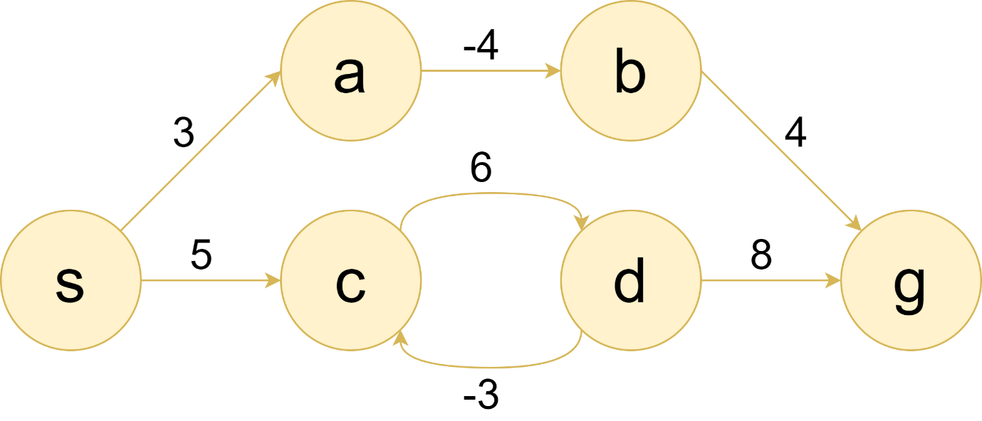

Write the code to find the shortest path from node ‘*s*’ to all other nodes using Dijkstra’s Algorithm. Can you get the proper results? Why?

Now consider that nodes ‘*e*’ and ‘*f*’ are added to the graph as given in the following diagram:

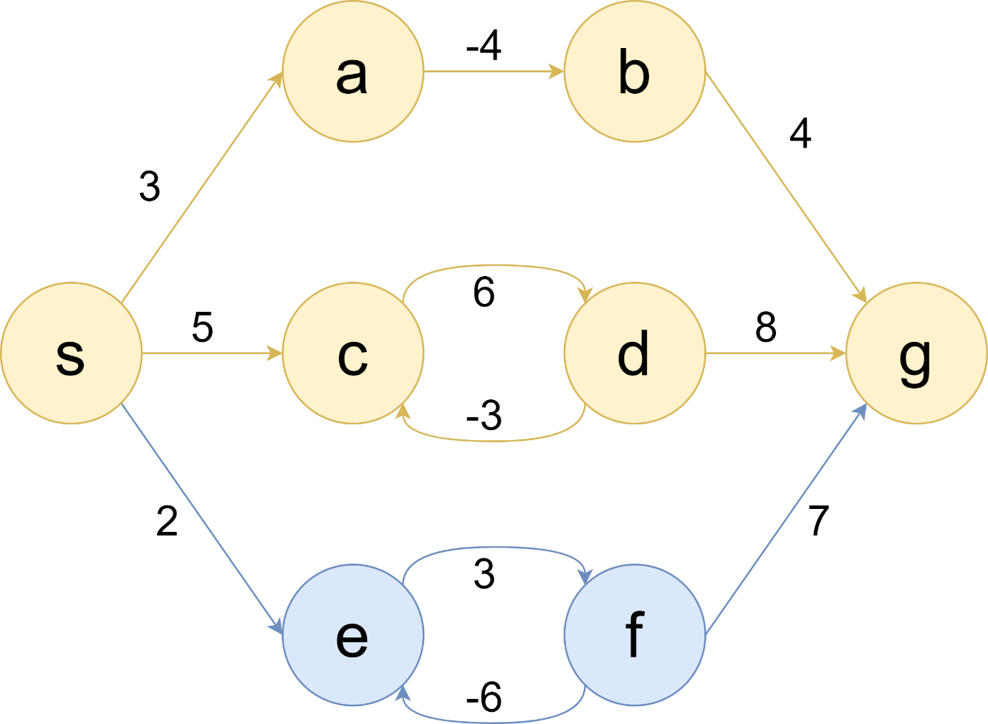

Does the code you wrote for Dijkstra’s Algorithm work on this graph? If not, then make necessary changes so that it can find single source shortest paths for graphs like this.

You can use an adjacency matrix to store the graphs.